Investment 1: Expansion of Very High Capacity Networks in underserved areas

# High-level project description

Objective: ensure that: (a) All premises in organized communities (urban or rural) have access to internet connectivity offering a download speed of at least 100Mbps, which can be readily upgradable to 1 Gbps; (b) 100% of the population living in organized communities (urban or rural), and all major terrestrial transport paths have uninterrupted 5G coverage with a download speed of at least 100 Mbps; and (c) Gigabit connectivity for all main socio-economic drivers.

Currently several areas of Cyprus remain white areas, and large parts of the territory are not serviced with 100 Mbps speeds. This is true for both terrestrial and mobile connectivity. The declared investment plans from operators will leave significant gaps. It is unlikely that the coverage targets will be met unless incentive are put in place to attract private operators into underserviced areas of the country.

Challenges: The terrestrial and mobile connectivity interventions might require different State aid compliance. The timeline foreseen under the RFP is very tight and will require any State aid compliance and selection process to be achieved rapidly, so that the project can be implemented within the foreseen timeline.

Implementation: The Department of Electronic Communications (DEC) of the Deputy Ministry of Research, Innovation and Digital Policy (DMRIDP) will be the implementing authority. The implementation of the project will follow a Private DBO (Design, Build and Operate) - Gap Funding model (i.e., the Contractor will undertake the design, construction and operation of the network, as well as part of the financing, and the public sector will cover the funding gap with a grant), following an open tender procedure. The geographical territory of the Republic of Cyprus will be divided (indicatively) into 3 lots. For each lot, the maximum amount of public financial contribution will be set and awarding criteria will include the requested public support as well as the price offered to end-users and to other retail operators. Provisions will be made to ensure competition, for example, not all lots can be awarded to only one bidder. The network that will be developed in each lot will concentrate the traffic from all the served locations to one (or more) central Points-of-Presence (POPs), where other retail operators can be interconnected, in order to provide services. Wholesale obligations will be imposed to the Contractor, as per the State-Aid provisions.

Target population: The project location consists of discrete areas, scattered over the entire territory of the Republic of Cyprus. A mapping of existing and future private investments in fixed networks and 5G was recently performed by the NRA (OCECPR) for a timeframe of future investments until 2025. Based on the mapping of fixed networks, private investments are expected to serve areas where 90% of the population lives and cover 32% of the whole territory with services offering a download speed of at least 100Mbps, which can be readily upgradable to gigabit. For 5G networks, private investments are expected to cover 98% of the population and roughly 70% of the territory (including major terrestrial transport paths).

**Through the project, the population living as well as businesses of the remaining (underserved) areas, both in terms of fixed and 5G, will be covered. Furthermore 1436 buildings hosting major socio-economic drivers are expected to be covered with symmetric gigabit speeds.**

Project Maturity: The geographical scope of the project has been defined through a ‘detailed mapping and analysis of coverage’ exercise, compatible with the requirements of the Broadband guidelines (article 78.a of the EU Guidelines for the application of State aid rules in relation to the rapid deployment of broadband networks 2013/C 25/01). A detailed cost estimation has been performed and is included in the following chapter. The project has be included in the National Broadband Plan, which was put to public consultation in 2021. Technical assistance for the detailed project preparation (including State aid compliance and drafting of the tender documents) has already been assured through TSI.

# Detailed cost estimation

## Fixed Access (Objective a)

The private investment plans (up to 2025) submitted to OCECPRP during the January 2021 mapping were taken into account. The map shows in dark green the areas where private investment is expected to cover the 'objective a' of the Broadband Plan, and with light green areas where 'objective a' is not intended to be covered by purely private investments. It is noted that there are sub-areas - within dark green areas - where more than one network covering 'objective a' are to be deployed.

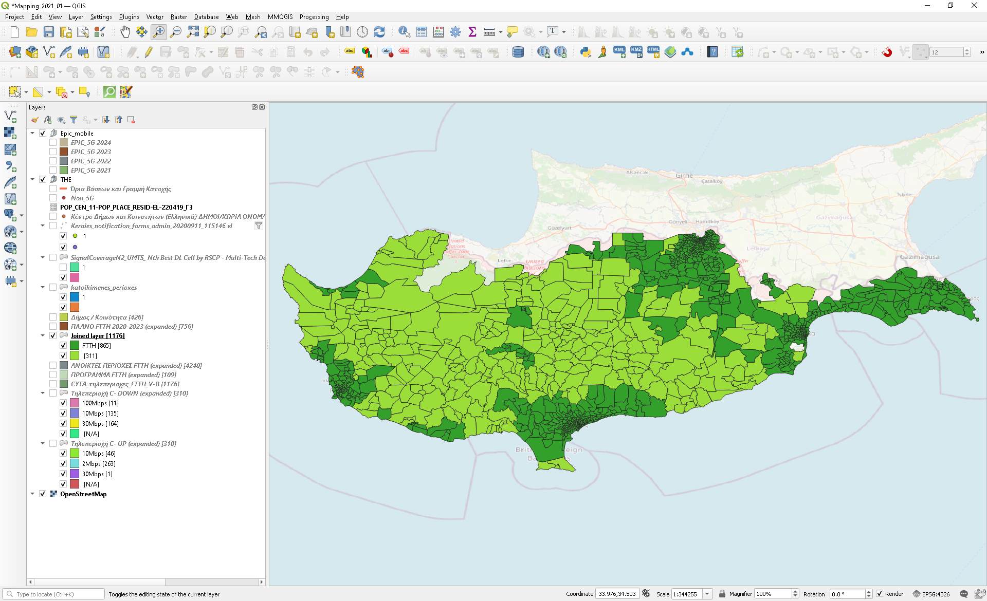

The target areas are those with light green and refer to 311 teleregions (out of 1176) and include 31,900 lines (out of 334K). The premises of these areas under objective a[[1]](#footnote-1) are estimated at 42,975 by applying the multiplier of 135% (which is the average for the whole of Cyprus, for all premises[[2]](#footnote-2) as percent of operating lines (all lines, even those not used for internet access services)[[3]](#footnote-3).

In order to approach the funding gap, Cyta's private investment is taken as the basis: The following table summarises the elements of the investment plan announced in 2018[[4]](#footnote-4).

|  |  |  |  |  |
| --- | --- | --- | --- | --- |
| **Premises** | **Investment** | **Cost per premise** | **Geographical area of the coherent part of the area (Km2)****[[5]](#footnote-5)** | **Density (Premises/ Km2) 4** |
| 200Κ | 120Μ | 600 € | 202.9 | 987 |

Since private investment areas focus on the most attractive (mainly urban and semi-urban areas where the coherent part of the area is characterised by a higher density), in order to approach deployment cost for the target areas, the following curve[[6]](#footnote-6) is used which correlates the cost of deployment with the household density. The cost per premise (600 €) resulting from the investment plan of Cyta shows a very good coincidence with the literature for the specific household density.

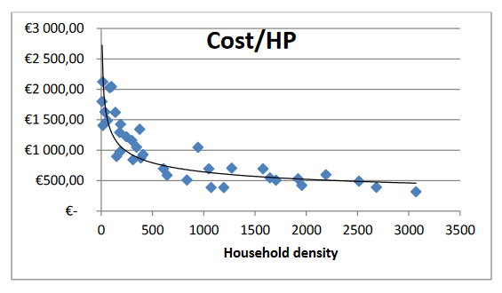

The following table summarises the quantitative characteristics of the areas expected to remain without coverage, as they are not part of the business development plans of any of the providers (as submitted in January 2021).

|  |  |  |  |
| --- | --- | --- | --- |
| **Based on provider investment plans up to 2025** | **Premises** | **Geographical area of coherent part of the area (Km2)** | **Density (Premises/ Km2)** |
| Out of coverage | 42.975 | 190 | 168 |

Using the previous curve, the development cost for the out of coverage areas is estimated at ~1250 €/premise leading to a total cost for the project of €53.7 million. It is therefore evident to consider as funding gap the additional cost that makes the overall project equally attractive to the private investment (1250-600=650 €/premises[[7]](#footnote-7),[[8]](#footnote-8)), leading to a total **funding gap of** **€27.9 million**. It is noted that this only includes the access part of the network, as the optical backhaul already exists, since these areas are already served through Vectoring / Bonding that require such a backhaul.

The map shows in blue the areas where private investments are expected to meet objective a, and in red the areas of no investment (that fall within the scope of Investment 1)

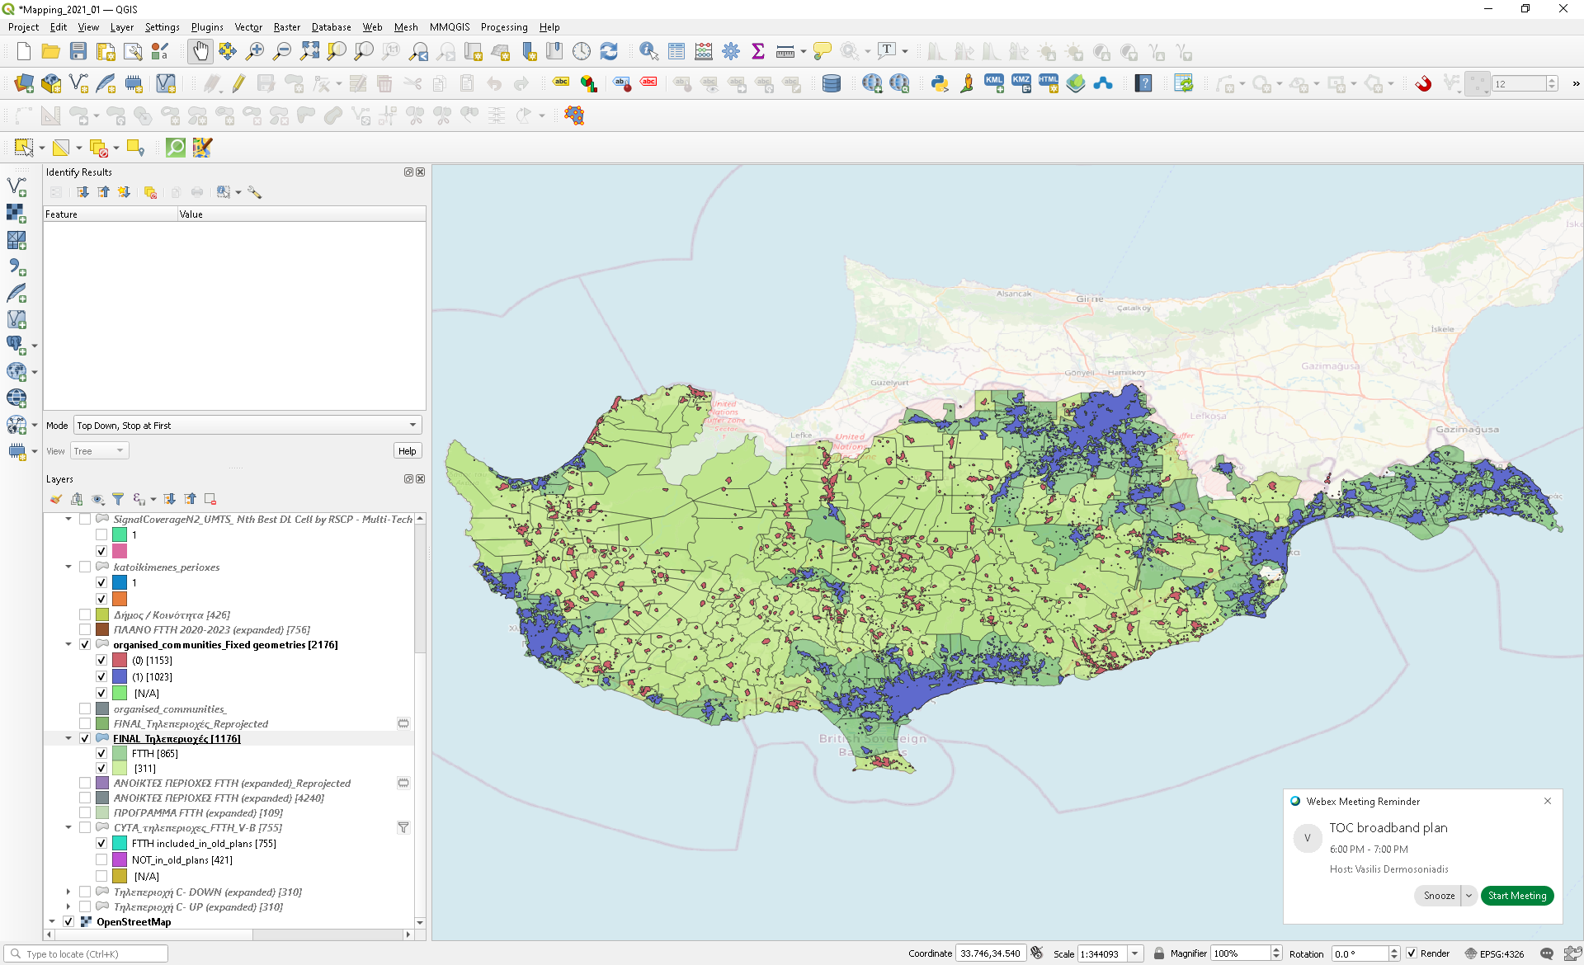

## Mobile access (objective b)

The objective of the intervention will be to accelerate and stimulate 5G coverage in areas of Cyprus which are not part of the coverage obligation of the spectrum owners. The conditions in Cyprus impose a 70% coverage of area, as well as all major road sections. This leaves close to 30% of the territory where State intervention might *a priori* be possible.

The most recent data provided by Cyta and EPIC show that the areas likely to fall outside the planned 5G coverage represent only XX% of the territory. It is in these areas that the aid schemes will channel support.

The private investment plans (up to 2025) submitted to OCECPRP during the January 2021 mapping were taken into account. EPIC provided a 5G coverage map, but Cyta did not, claiming that it was not in a position to do so. It did, however, made available the base stations for which it stated that it has no intention to install 5G equipment by 2025 - amounting to 80 (out of a total of 652 Cyta base stations). In order to simulate Cyta's coverage map, the coverage diagram resulting from the remaining base stations (652-80) for UMTS 900 Mhz with RSCP -102 dbm, Outdoor, Server 1 was used. The other two providers did not provide cartographic data.

The following illustration shows the coverage of Cyta (in purple) and EPIC (in brown) as well as the residential areas that are expected to remain without 5G coverage (in blue)

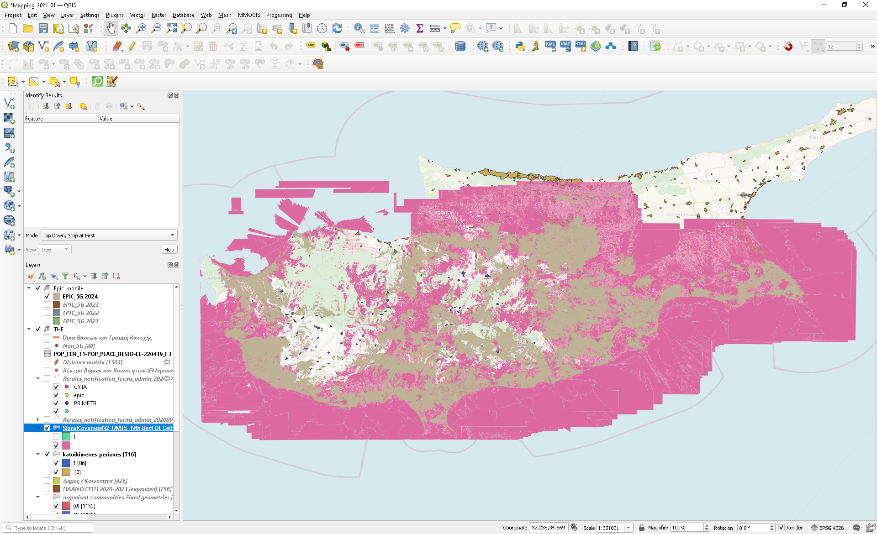

Although in terms of geographical coverage the part of Cyprus that will remain without coverage is large, at population level the residential areas (not covered in whole or in part) amount to 159 with a total population of ~21,860 inhabitants.

In an urban environment, in addition to upgrading the radio equipment of the existing base stations, it is expected that there will be a significant densification with systematic deployment of small-cells (which will typically use the higher frequencies of 3.6 or even 26 Ghz – although for the 26 Ghz band there has been no strong interest and was not included in the latest spectrum auction, this need is expected as end-user speed requirements will increase over time). However, in a sparsely built environment (rural areas), the range of 700 Mhz and 3.6 Ghz are sufficient in order to both maximise geographical coverage and to offer the highest possible speeds through the macro-cell. In these areas, no significant densification of the network is expected as in urban areas. In rural areas it is expected that only few small-cells will be developed where traffic is concentrated (e.g., on the bell-tower of the church of a large village). Therefore, in order to serve rural areas at speeds of 100 Mbps, it is estimated that small-cells will need to be deployed only in large villages served by macro-cells that are already congested. Therefore, for the target regions, the deployment of a 5G network primarily refers to upgrading the radio equipment of macro-cells (i.e., existing base stations covering a large area), and secondly to the need of densifying the network by adding additional base stations (i.e. small-cells inside macro-cells), where needs exceed macro-cell service capabilities.

Based on theoretical specifications, 5G supports end-user speeds ~ 100 Mbps for device density of 1,000 per Km2[[9]](#footnote-9). In order to estimate the need for small-cells, we use the population of each of the 159 residential areas (which are served by the 80 macro-cells) and we assume that in real conditions end user speed of ~ 100 Mbps can be supported for up to 200 users. The following table summarises the number of villages with respect to their population:

|  |  |
| --- | --- |
| **Population served by each macro-cell** | **Number of villages** |
| 500-1000 | 6 |
| 200-500 | 32 |
| <200 | 121 |

In the most pessimistic scenario, network densification will be needed for 38 macro-cells, with a densification factor not exceeding 2x. Therefore, the scope of the project includes the following:

|  |  |
| --- | --- |
| *New small-cells (sites) that will need to be deployed* | 38 |
| *Cost per new small-cell**[[[10]](#footnote-10)](https://www.translatoruser.net/bvsandbox.aspx?&from=el&to=en&csId=ad9ca9d9-90d6-483f-b9ae-f167bd419c5a&usId=115c599c-f09f-4ff8-8c33-416c60bede62&bvrpx=false&bvrpp=&dt=2021%2F3%2F12%209%3A46" \l "_ftn10" \o ")* | 15000 |
| *Macro-cells for which radio equipment upgrade will be needed* | 80 |
| *Cost fo**r radio equipment per macro-cell[[11]](#footnote-11)* | 40000 |
| *Macro-cells for which optical backhaul and radio-equipment upgrade will be needed (considering that none of the 80 have optical backhauling)* | 80 |
| *Cost for optical backhaul[[12]](#footnote-12)* | 60000 |
| **Total (million €)** | **8.6** |

Since there is no comparative data to estimate the funding gap, the same percentage is taken as that used for fixed access, i.e. 52%, which results in a funding gap of **€4.5 million.**

## Gigabit connectivity for SED (objective c)

Entities falling within the definition of the main Socio-Economic Drivers (SED) include educational institutions of all levels (primary, secondary and higher education), hospitals and buildings housing government agencies of the central and regional administration, in total 1436 entities.

* 350 primary education buildings
* 186 secondary school buildings
* 75 universities and other higher education buildings
* 87 Hospitals
* 738 buildings housing government agencies of central and regional administration

It is noted that SEDs are scattered throughout Cyprus, but no extensive work will be needed to make these connections possible, as by 2025 all SEDs are expected to be ‘passed’ (either through private investments or through the fixed access part of the current investment) – i.e., fibre optic infrastructure will be available near them.

However, as all providers deploying very high-capacity networks (FTTH and cable) in Cyprus use a point-to-multipoint topology (GPON and DOCSIS), only asymmetric services are offered, reaching 1 Gbps on the downlink but limited to significantly lower speeds on the uplink (typically 1Gbps download / 100 Mbps upload). This is also the case for the few SEDs that are currently served by fiber (mainly schools recently upgraded to fiber). In order to provide symmetrical gigabit speeds on these networks, it is necessary to configure the network properly, in the network part that starts from the node (OLT) up to the point that hosts the SED. This configuration can be done either at the passive level (point-to-point) or at active level with the addition of appropriate terminal equipment (WDM-PON). In any case, even if an optical network passes near a SED, additional work/configurations will be needed to provide symmetric gigabit service.

Therefore, for the purposes of costing, all SEDs (either already served or to be served in the future by GPON) are taken into account. Indicative cost per point is EUR 1750 based on which a total cost of €2.5 million is estimated.

The following table summarises the total cost and total funding gap for the three sub-parts of Investment 1.

|  |  |  |
| --- | --- | --- |
| **Investment 1** | **Total cost (million €)** | **Funding gap (million €)** |
| Fixed Access (objective a) | 53.7 | 27.9 |
| Mobile access (objective b) | 8.6 | 4.5 |
| Gigabit connectivity for SED (objective c) | 2.5 | 2.5 |
| **Total** | **64.8** | **34.9** |

# Risk estimation

## Context risks

Expected behavior of the future private investors and state-aid issues: In the past, there have been no major public intervention projects in Cyprus in the broadband sector. Apart from Cyta, which is expected to participate in the procurement process, it is unknown whether there will be interest from other potential private investors to assure an adequate level of competition. This should be taken into account when deciding the procurement approach that will be followed as well as the potential implications concerning State aid compliance. State aid compliance is required, in accordance with Broadband Guidelines (2013/C 25/01). According to the final version of the updated GBER, State aid notification may not be necessary, or may be necessary only for certain parts of the investment[[13]](#footnote-13). It is therefore of paramount importance to consistently follow the State aid requirements during the project maturation and preparation. It is also important to keep the interested parties adequately informed regarding the project.

Demand for higher speeds in rural areas is another key element that will drive operators’ interest. The NRA has carried out a survey in 2021[[14]](#footnote-14), which has shown that for urban areas, the interest of households for high speeds is 97%, whereas in rural areas it is only 89%. This is still a very high percentage, which would indicate that the up-take of the higher speed offerings in the rural areas will not be significantly lower than in the more urban parts of Cyprus.

Project viability: Assuming that the funding gap is covered by public funds, project viability largely depends on end-user demand. The demand for high quality and high-speed broadband services is constantly increasing as the value that end users receive from these services becomes more and more important. Furthermore, in the project intervention areas, a copper switch-off process maybe foreseen in order to guarantee end-user demand. This is in line with the voluntary copper switch-off approach followed by Cyta in the areas where FTTH is deployed. With proper design, modern telecommunications networks have extremely low operating costs and therefore no substantial viability risks are expected.

Inadequate cost estimate/ Insufficient committed funding: Cost estimation has taken into account the level of returns that is expected by potential private investors. In the unlikely event that the cost estimate and the related committed funding proves to be insufficient, the project areas could be prioritised in order to assure coverage of the most remote/sparsely populated areas and leave the most profitable (amongst the project scope areas) to be covered in the future by private investments.

## Administrative and procurement risks

Delays in project preparation/procurement: Funding for the technical assistance during project maturation and preparation has already been assured. It is important to allocate adequate resources from the project promoter as well as to assure smooth and efficient decision-making procedures from the early stages of the project preparation until the end of the procurement process. Taking into account that the project should be finalized by mid-2026, the actual project implementation duration should be foreseen in a realistic way to allow for potential delays in the preparation and procurement phases.

Operational and financial risks: The constructed network should be operated by a telecom operator with adequate experience and expertise, as well as access to financial resources to limit operational and financial risks. It is therefore important to make sure that the tender criteria assure minimum level of technical and financial capabilities for the potential builders.

# State aid compliance

Introduction

The Cypriot telecoms market has the particularity that the 4 existing operators are active on both the fixed and mobile segments. All operators acquired frequencies for the 700 MHz and the 3.6 Ghz bands. As such from a market operator perspective there is no differentiation between the two markets. This is of importance when considering the State aid compliance of the aid scheme. Indeed, as all operators are active on all segments - the support schemes can therefore be considered jointly for the assessment of the impact on competition, as no operator will be excluded from participating in the aid scheme.

The Cypriot telecom market is dominated by the historic operator, Cyta. Cyta covers X% of the fixed market and X% of the existing mobile market.

Based on the market consultation that was carried out in 2021 the investment plans of the four operators would not significantly change the balance of the market. Based on the projected private investment Cyta will retain its dominant position in the market.

There are some infrastructure sharing agreements between operators with a view to drive the roll out of 5G.

Fixed connectivity support

The support to fixed connectivity is planned throughout the territory of Cyprus. Based on the mapping carried out in 2021, which reflects the current installation base, as well as investments planned by the operators by 2025 there will be two types of intervention areas remaining. These areas will not be covered by private investment by 2025. They fall into two categories:

* Areas where the download speeds available to users are below 30 Mbps
* Areas where the downloads speeds available to users are above 100 Mbps, but with no possibility to up-grade to 1 Gbps

These are the two areas that will be targeted by the public intervention. Overall, this represents fewer than 50.000 connections, including households, businesses and SEDs.

1. State aid compliance

The Commission usually encourages Member States to design their State aid schemes in line with the provisions of the GBER and avoid notification where possible. New rules concerning aid for broadband infrastructures were recently introduced in the GBER. Among those, Article 52, which concerns aid for fixed broadband networks.

In line with Article 52(1) GBER, aid for fixed broadband network deployment shall be compatible with the internal market pursuant to Article 107(3) of the Treaty and shall be exempted from the notification requirement of Article 108(3) of the Treaty, provided that the conditions laid down in Article 52 and in Chapter I concerning common provisions of the GBER are fulfilled.

Article 52(2) identifies the following eligible costs:

* All costs for construction
* All costs for management
* All costs of operation of a fixed broadband network

The maximum aid amount for a project shall be established on the basis of an open, transparent and non-discriminatory competitive selection procedure in line with the principles of public procurement rules and respecting the principle of technical neutrality (Article 52(2) read together with Article 52(6)(a) GBER).

Article 52(3) GBER lists alternative types of investments that are eligible:

(a) fixed broadband network deployment **to** **connect households and socioeconomic drivers** in areas where there is no network able to reliably provide speeds of **at least 30 Mbps download** (threshold speeds) present or credibly planned to be deployed within three years from the moment of publication of the planned aid measure or within the same time horizon as the deployment of the subsidised network, which shall not be shorter than two years. This shall be verified by mapping and public consultation in accordance with paragraph 4. Areas with at least one present or credibly planned network able to reliably provide speeds of at least 30 Mbps download shall be excluded. The aided network shall ensure at least a doubling of download and upload speeds compared to the present or credibly planned networks and shall be able to reliably provide at least 30 Mbps download speeds (target speeds);

(b) fixed broadband network deployment **to connect households and socioeconomic drivers** in areas where there is no network able to reliably provide speeds of **at least 100 Mbps** download (threshold speeds) present or credibly planned to be deployed within three years from the moment of publication of the planned aid measure or within the same time horizon as the deployment of the subsidised network, which shall not be shorter than two years. This shall be verified by mapping and public consultation in accordance with paragraph 4. Areas with at least one present or credibly planned network able to reliably provide speeds of at least 100 Mbps download shall be excluded. The aided network shall ensure at least a doubling of download and upload speeds compared to the present or credibly planned networks and shall be able to reliably provide at least 300 Mbps download and 100 Mbps upload speeds (target speeds);

(c) fixed broadband network deployment **to connect only socioeconomic drivers** in areas where there is only one network able to reliably provide speeds of at least 100 Mbps download but below 300 Mbps download (threshold speeds) present or credibly planned to be deployed within three years from the moment of publication of the planned aid measure or within the same time horizon as the deployment of the subsidised network, which shall not be shorter than two years. This shall be verified by mapping and public consultation in accordance with paragraph 4. Areas with at least one present or credibly planned network able to reliably provide speeds of at least 300 Mbps download shall be excluded. Areas with at least two present or credibly planned networks able to reliably provide speeds of at least 100 Mbps download shall also be excluded. The aided network shall ensure at least a doubling of download and upload speeds compared to the present or credibly planned networks and shall be able to reliably provide at least 1 Gbps download speeds (target speeds).

|  |  |  |
| --- | --- | --- |
| **Article 52(3)(a)** | **Article 52(3)(b)** | **Article 52(3)(c)** |
| Deployment to connect households and socioeconomic drivers | Deployment to connect households and socioeconomic drivers | Deployment to connect only socioeconomic drivers |
| Must have no network able to reliably provide speeds of at least 30 Mbps download | Must have no network able to reliably provide speeds of at least 100 Mbps download | Must have only one network able to reliably provide speeds of at least 100 but below 300 Mbps download |
| Areas with at least one present or credibly planned network able to reliably provide speeds of at least 30 Mbps download shall be excluded | Areas with at least one present or credibly planned network able to reliably provide speeds of at least 100 Mbps download shall be excluded. | Areas with at least one present or credibly planned network able to reliably provide speeds of at least 300 Mbps download shall be excluded. Areas with at least two present or credibly planned networks able to reliably provide speeds of at least 100 Mbps download shall also be excluded. |

Based on these provisions and the objectives of this plan, we conclude that:

1/ The areas in Cyprus where the download speeds available to users are below 30 Mbps fall under Article 52(3)(a) GBER. They can therefore pass through GBER.

2/ The areas in Cyprus with only one access network for SEDs of at least 100 Mbps but below 300 falls under Article 52(3)(c) GBER. They can therefore go through GBER as well.

3/ However, the areas where the download speeds available are already above 100 Mbps do not seem to qualify for deployment for households under the GBER.

As can be seen from the table, Article 52(3)(b) GBER holds that deployment for households are possible only for areas where no networks are currently able to provide at least 100 Mbps. There is an explicit exclusion of areas with at least one network present able to reliably provide speeds of at least 100 Mbps.

Therefore, all areas where download speeds are currently available above 100 Mbps may not benefit from public intervention for further deployment to connect households under GBER. This does not mean that State aid cannot be granted for this purpose. It implies that a notification is necessary for the Commission to assess the compatibility of the measure.

On that basis, planned intervention under GBER would be limited to:

* areas with speeds below 30 Mbps to connect both households or SEDs (Art 52(3)(a))
* areas with only one access network of at least 100 Mbps but below 300 Mbps would qualify, but only to connect SEDs (Art 52(3)(c))

Other GBER conditions to respect

* Presence of a step change – In this case by shifting from FTTC to FTTH (vectoring to fibre, asymmetrical services to symmetrical)
* Open competition for all market operators to participate, must be transparent
* Mapping – already done
* Prior consultation of market, which includes verification of the mapping
* Member States shall put in place a monitoring and claw-back mechanism
* All aid beneficiaries will have to provide wholesale access to the supported infrastructure.

1. Mapping

According to Article 52(4)(a) GBER, the mapping shall identify the geographic target areas envisaged to be covered under the public intervention and shall take into account all present public and private networks able to reliably provide the threshold speeds identified above depending on the type of investment.

The mapping for the identification of the intervention areas was carried out in XXX 2021. Based on the operators’ response the NRA has developed a detailed atlas of the different areas of the territory. Annex XXX shows the exact planned intervention areas. Annex XXX shows the areas where private investment will provide the required speeds of 1 Gbps by 2025. As the plans are recent and the consultation was carried out less than a year ago, with a communicated horizon of 2025 no new mapping is planned prior to the market consultation (see below).

It does not seem to be necessary to proceed with a new mapping given that the last one was carried out recently, covered a reasonable time horizon in line with the GBER requirements and as long as in the upcoming public consultation the list of geographic target areas identified in the mapping exercise is properly verified.

1. Market consultation

Further to the pre-notification and ensuing discussions with the European Commission a public consultation will be carried out. This is planned in late Q1, early Q2 2022. The consultation will:

* Last at least 30 days
* Present the planned intervention scheme
* Include the planned intervention areas (three lots – tbc). The mapping must be verified.
* The conditions for participation in the scheme
* The co-funding conditions, as well as payment conditions
* The selection criteria
* Monitoring & claw back mechanism

The market consultation will allow to clarify certain key points:

* The general interest of the operators to participate
* If any planned intervention is foreseen to be covered by private investment in the next 3 years
* Possible technology mixes
* Feedback on the selection criteria
* Feedback on the claw back mechanism
* Feedback on the lots

Based on the consultation’s outcome a final intervention map will be defined.

If required, adaptions will be made to the planned aid scheme (funding conditions, selection criteria, claw back, etc).

Notification for areas above 100 Mbps for further deployment to connect households

Areas with at least one network present able to reliably provide speeds of at least 100 Mbps **will have** to be notified for further deployment to connect households (make them readily upgradable to 1 Gbps).

Notification entails two conditions to consider regarding compatibility under Article 107(3)(c):

1. facilitation of the development of an economic activity:

* networks as facilitators of economic activities
* incentive effect
* compliance with other provisions of Union law

1. the aid measure must not unduly affect trading conditions to an extent contrary to common interest:

* the positive effects of the aid,
* the necessity for State intervention (the existence of the market failure will have to be explained)
* the appropriateness of the aid measure as a policy instrument,
* the proportionality of the aid measure,
* the negative effects on competition and trade as well as weighting the positive effects of the aid against the negative effects on competition and trade.

All of these points will have to be expanded upon in the notification.Mobile connectivity support

The intervention scheme for mobile connectivity will aim to achieve full coverage of all premises and all major transport corridors with 5G by 2025.

The current coverage obligations of the operators only require a 70% of the population to be covered. The market consultation carried out in October - November 2021 has shown that private operators plan to cover the close to 90% of households and XXX% of the territory. This leaves around 10% of households that would not be covered. The planned scheme aims to ensure full coverage for these market failure areas.

The aid scheme will fund the backhaul connection of base stations, and in some cases the creation of new base stations in order to ensure adequate coverage that permits 5G coverage in rural and mountainous areas of Cyprus. Active equipment is not planned to be supported by the scheme. All aid beneficiaries will have to provide wholesale access to the supported infrastructure.

1. State aid compliance

New rules concerning aid for broadband infrastructures were recently introduced in the GBER. Article 52a regulates the conditions to grant aid for 4G and 5G networks that can be block-exempted.

Article 52a. 2 identifies the following eligible costs:

* All costs for construction
* All costs for management
* All costs of operation of a fixed broadband network

The maximum aid amount for a project shall be established on the basis of an open, transparent and non-discriminatory competitive selection procedure in line with the principles of public procurement rules and respecting the principle of technical neutrality (Article 52a.2 read in conjunction with Article 52a.7(a)).

Article 52a provides that 5G investment shall be located in areas where mobile networks have not been deployed or where only mobile networks able to support mobile services of up to 3G are available and where there are no 4G and no 5G mobile networks present or credibly planned to be deployed within three years from the moment of publication of the planned aid measure or within the same time horizon as the deployment of the subsidised network, which shall not be shorter than two years.

Most of the planned intervention areas are currently covered by 4G. The intervention scheme would therefore not fall under GBER.

DEC therefore plans a submission for approval of the State aid scheme to DG COMP.

Notification entails two conditions to consider regarding compatibility under Article 107(3)(c):

1. facilitation of the development of an economic activity:

* networks as facilitators of economic activities
* incentive effect
* compliance with other provisions of Union law

1. the aid measure must not unduly affect trading conditions to an extent contrary to common interest:

* the positive effects of the aid,
* the necessity for State intervention (the existence of the market failure will have to be explained)
* the appropriateness of the aid measure as a policy instrument,
* the proportionality of the aid measure,
* the negative effects on competition and trade as well as weighting the positive effects of the aid against the negative effects on competition and trade.

All of these points will have to be expanded upon in the notification.

The new Broadband guidelines provide that a market failure might thus exist in the presence of a 4G or even a 5G network where such a network does not and is not likely to provide end-users with sufficient quality of services to satisfy their evolving needs. For the notification, the necessary reasoning will be elaborated in line with these criteria.

1. Mapping

The mapping shall identify the geographic target areas envisaged to be covered under the public intervention and shall take into account all present public and private networks able to reliably provide the threshold speeds identified above depending on the type of investment.

The latest consultation of market operators took place in XXX 2021. Only two operators (EPIC & Cyta) provided their 5G plans. As the mapping is less than a year old, and had a time horizon to 2025 we do not consider it necessary to carry out a new mapping prior to the planned market consultation (see below). It is not necessary to proceed with a new mapping given the recency of the last one and as long as it is verified in the upcoming public consultation.

The planned intervention areas are limited to market failures areas, that notably:

* Fall outside the coverage obligation of spectrum owners
* Where no private investment is planned by 2025 to provide reliable 100 Mbps mobile connectivity

1. Market consultation

Further to the pre-notification and ensuing discussions with the European Commission a public consultation will be carried out. The consultation will:

* Last at least 30 days.
* Present the planned intervention scheme
* The planned intervention areas (three lots – tbc). The mapping must be verified.
* The conditions for participation in the scheme
* The required service level to be provided (ie 100 Mbps reliable mobile connectivity)
* The co-funding conditions, as well as payment conditions
* The selection criteria
* Monitoring & claw back mechanism

The market consultation will allow to clarify certain key points:

* The general interest of the operators to participate
* If any planned intervention is foreseen to be covered by private investment in the next 3 years
* Feedback on the selection criteria
* Feedback on the claw back mechanism
* Feedback on the lots

Based on the consultation’s outcome a final intervention map will be defined.

If required adaptions will be made to the planned aid scheme (funding conditions, selection criteria, claw back, etc).

**Scenarios for next steps**

The pre-assessment of the aid scheme above shows that not all of the fixed line interventions would fall under GBER, whereas the support to the mobile connectivity would not fall under GBER at all.

The notification would therefore have to cover the fixed line intervention for households in areas where an existing network offers speed above 100 Mbps as well as all the interventions for mobile connectivity.

In this regard, it is interesting to underline that the draft broadband guidelines published by the European Commission in December 2021 state that mobile and terrestrial broadband are to be treated as two distinct markets.

Although indeed the mobile market and the fixed line market are also distinct in Cyprus, the operators are the same. There are four active telecom operators in Cyprus. All are active in fixed lines, and all four own spectrums for the roll out of 4G & 5G. As such they compete equally in both market segments. In both market segments the historic operator Cyta is dominant. Based on the outcome of the mapping market consultation this dominant position will remain roughly the same in the coming years based on projected private investments. As such, the planned aid schemes could be construed in such a manner to offer an opportunity to stimulate competition in the market and provide an opportunity for emerging operators to take a more prominent role in certain areas.

A question therefore arises as to whether the interventions should be treated jointly or separately. Should the fixed line interventions (below 30 Mbps & SEDs) pass with GBER while the rest is notified? Or should the whole plan be notified? The following section tries to explore the respective advantages of the two options.

|  |  |
| --- | --- |
| **Advantages of a single scheme** | **Advantages of two schemes** |
| A single aid scheme to be managed by DEC:   * Important in terms of human resources * Important in terms of managing tight timelines | Allows the lots for mobile and fixed lines to be different, thereby reflecting different failure areas. |
| Considering that not all fixed line interventions fall under GBER (hence must also be notified), a common notification for everything would be more logical. | Allows differentiated lot allocation to operators, thereby having a more differentiated impact on the competitive environment of the market |
| If (pre-)notified, allows clarification of certain project elements with the European Commission.  Legal clarity and certainty on all aspects. | Ensures that some of the terrestrial connectivity can be rolled out soon, under GBER, saving time in roll out start |
| Under a single scheme some freedom in allocating funds to where required / needed / most impactful |  |
| Commission puts priority on RRF schemes. This ensures a rapid decision to the notification. |  |
| Reduced unit costs for base station if combined with fibre roll out |  |

**Questions to address to decide on which scenario to follow**:

* Is a differentiated lot allocation for mobile and fixed desired to stimulate competition?
* Does DEC have the resources to prepare and run two schemes?
* Are the RFF milestones such that an accelerated fixed roll out would actually allow the claiming of RRF funds
* If two schemes are managed, how difficult would it be for DEC to reallocate funds between the schemes in case of need?

# Cashflows per year

See attached project worksheet

# Detailed timeplan

See attached project worksheet.

Detailed project plan attached.

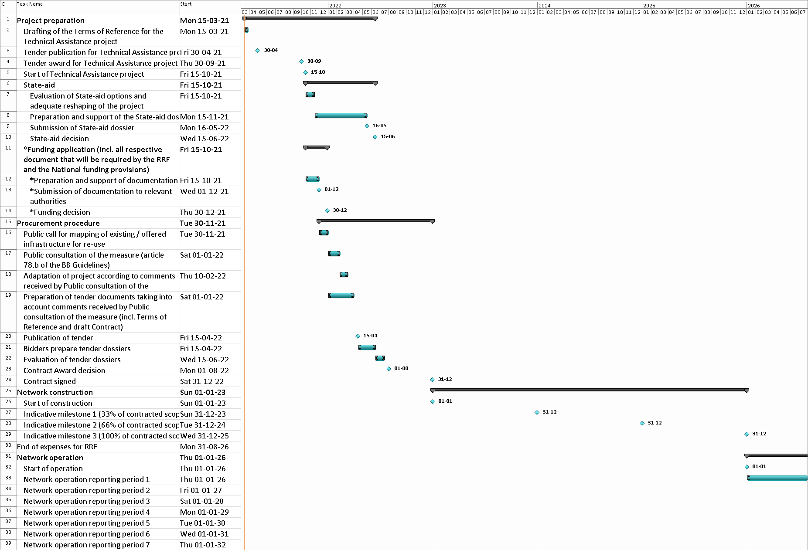

# Milestones, targets

See attached project worksheet

1. Premises are defined as all premises housing households or businesses within the boundaries of organised communities as well as active enterprises employing more than 10 workers, even if they are outside the boundaries of organised communities. [↑](#footnote-ref-1)
2. Total premises= 433212, <https://www.mof.gov.cy/mof/cystat/statistics.nsf/All/59681B67FE82FD39C2257AD90053F3FA/$file/POP_CEN_11-POP_PLACE_RESID-EL-220419.xls?OpenElement> Table Γ3 [↑](#footnote-ref-2)
3. Total lines= 321568, <https://ocecpr.ee.cy/sites/default/files/ec_report_fiixedtelephonybroadbandtelecombulletin_gr_18-09-2020_pkmp.pdf> [↑](#footnote-ref-3)
4. <http://www.cytawholesale.com.cy/el/file/iBA3gjr5cdfGpdeP_+CepQ==/> 14-10-2018 [↑](#footnote-ref-4)
5. Calculations based on the data provided by Cyta as well as the boundaries of the organised communities as identified in the GIS [↑](#footnote-ref-5)
6. The Cost of Meeting Europe’s Future Network Needs , FTTH Council Europe <http://ftthcouncil.eu/documents/Reports/2017/FTTH%20Council%20Cost%20Model%202017_final.pdf> [↑](#footnote-ref-6)
7. In very good coincidence with 'The role of State Aid for the broadband networks rapid deployment of in the EU' (<https://op.europa.eu/en/publication-detail/-/publication/d6b8368d-f3dd-11ea-991b-01aa75ed71a1/language-en>) which refers to --> Average aid per line is expected to amount to around €640, with total investmentsof around) €940 per line. [note: The'total investment of around €940 per line'is weighted between FTTH and FTTCprojects, as in the case of State aid projects examined both access technologies are included) [↑](#footnote-ref-7)
8. The 'aid intensity' amounts to 52% of the investment, as opposed to the 68% given as an average in 'The role of State Aid for the broadband networks rapid deployment of in the EU'   [↑](#footnote-ref-8)
9. 5G Infrastructure Requirements in the UK [↑](#footnote-ref-9)
10. Future Use Cases for Mobile Telecoms in the UK (<https://assets.publishing.service.gov.uk/government/uploads/system/uploads/attachment_data/file/581437/Real_Wireless_Future_Use_Cases_for_Mobile_UK.pdf>) [↑](#footnote-ref-10)
11. 5G Infrastructure Requirements in the UK (<https://nic.org.uk/studies-reports/connected-future/5g-infrastructure-requirements-for-the-uk-ls-telcom-report/>) [↑](#footnote-ref-11)
12. Estimation that the average network length from the nearest route (since the base stations are mainly located on hills and a new route will be required) amounts to 2Km with an average cost per km of network of 30K€ / km [↑](#footnote-ref-12)
13. See recital 23 regarding revision of Article 52, 3b (i): “*As concerns connectivity for households:* *in areas where the one and only NGA network present or planned cannot reliably provide speeds of 100 Mbps download or more.*” and 3b (ii): “*As concerns connectivity for socio-economic drivers: in areas where the one and only NGA network present or planned cannot reliably provide speeds of at least 200Mbps symmetric or more than 500Mbps download.*” [↑](#footnote-ref-13)
14. The study has not yet been published, and data can be shared by the NRA if required. [↑](#footnote-ref-14)